Beast Report - 21 July 2019 from Dave Botherway

Buying :

With his Optus HFC-NBN still going great, Dave latest invoice included a strange extra credit of $3.53 for previous overcharging, but already credited last month ? He would not be “chasing Optus” over that difference . . .

Questions :

What is an ISO file ? A physical image (rather than file copies) of complex disk formats as used in video DVDs and bootable Windows DVDs,

What is .NET (and why is it being added ) ? .Net is part of Windows to provide a common interface for developers across multiple device types. There are many versions of .Net, so when installing an App that uses a different .Net version, it will call for the needed .Net version (ex Microsoft) to be also installed…

Main Topic : MelbPC ID, Email usage and Office-365

All MelbPC members have an ID with format of usename@melbpc.org.au. Besides being used to access Members-Only areas of our website, it is also an Email address with full mailbox facilities provided by Microsoft - so is actually a Microsoft ID.

Email can be accessed as Web Mail using a browser, or saved and processed on the PC using a client such as Windows Mail (part of Win10) , Outlook (within Office-365), Eudora, Thunderbird etc.

Whereas MelbPC membership includes the cloud version of Office-365, a desktop version can be purchased via MelbPC for an extra annual subscription of $65.

Alternatively, one-time purchase is possible for versions such as Office 2019 Home&Student, Office 2019 Home&Business and Office 2019 Business Pro . . .

Officeworks pricing examples being :
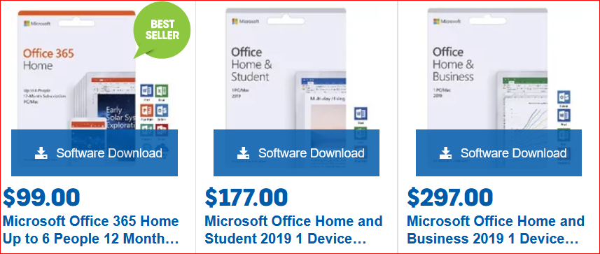
(MPC-$65)

Next Month . . .

A new PC – what extra programs do we get, what extra do we need ?

