Beast Report - 18 August 2019 from Dave Botherway

Six apologies for absence, with two new attendees welcomed

Questions :

“ I have copied 3 files totalling 5 GB onto a 16 GB USB, but when I try to add a fourth file of 4.3 GB, it says “too big for the memory stick” – that has 10+ GB left ?

Suggested that the “error message” relates to size of file being copied, rather than the remaining space. Issue being the USB stick is probably FAT-32 format, with maximum individual file size of 4 GB. Solution is to convert the USB stick to NTFS format where max file size is several magnitudes larger !

What is a VPN ? Question deferred, to be a fuller presentation next month . .

Scam and Virus Warnings :

August-13th warning ex StaySmartOnline.gov.au about dangerous BlueKeep virus applicable to Windows-7 and earlier versions – the latest Windows updates should be applied ASAP.
Similar warnings about ATO scams at this time of year and Western Union “prizes”.

Main Topic - Wanted / Unwanted Software

New PCs often have additional trial apps installed (called bloatware) that users may not want - question then becomes which to Uninstall. One useful tool is at www.shouldiremoveit.com that analyzes installed software with recommendations.

Free PC software sources:  techsupportalert.com  (Gizmo – as shown)  filehippo.com  freewarefiles.com  filehorse.com  download.cnet.com  techspot.com/downloads | 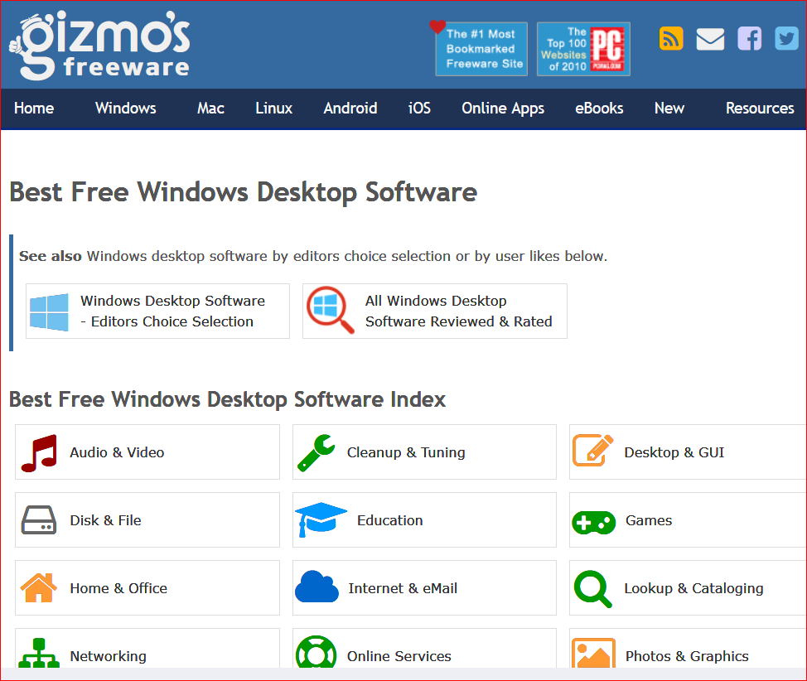

Next Month . . . Windows OneDrive, VPNs – What and Why ?

