Beast Report - 16 Feb 2020 report by Dave Botherway

Due to renovations in our normal room, February meeting was in the “Nursery” area ! . .

Questions :

1. Can I use a Sandbox or a RAM drive for Downloads ? Key issue here is the differences - a Ram drive “disappears” when PC is turned off, as does a Sandbox – but they serve two different purposes. The RAM drive is used for fast temporary storage, whereas a Sandbox is used to protect the main O/S while testing a new (or dubious) application.

2. Is it still possible to get free-upgrade from Win-7 to Win-10 ? Seemingly yes, see URL
https://www.zdnet.com/article/heres-how-you-can-still-get-a-free-windows-10-upgrade/

3. Some strange files showing up in File Explorer ? Maybe the option to view system files has been selected ? Go to File Explorer / View / Options / Change Folder & Search options, then View, tick Show Hidden Files Folders and Drives . . .

Interesting URLs :
For status of the coronavirus epidemic, see interesting Dashboard at

https://www.arcgis.com/apps/opsdashboard/index.html#/bda7594740fd40299423467b48e9ecf6

Main Topic – Email Clients

For offline email use, it is best to use an Email client such as Office Outlook, Windows Mail, Thunderbird etc But while some Email servers can auto populate the Client, it is sometimes necessary to manually input the Incoming and Outgoing parameters – see diagram below.

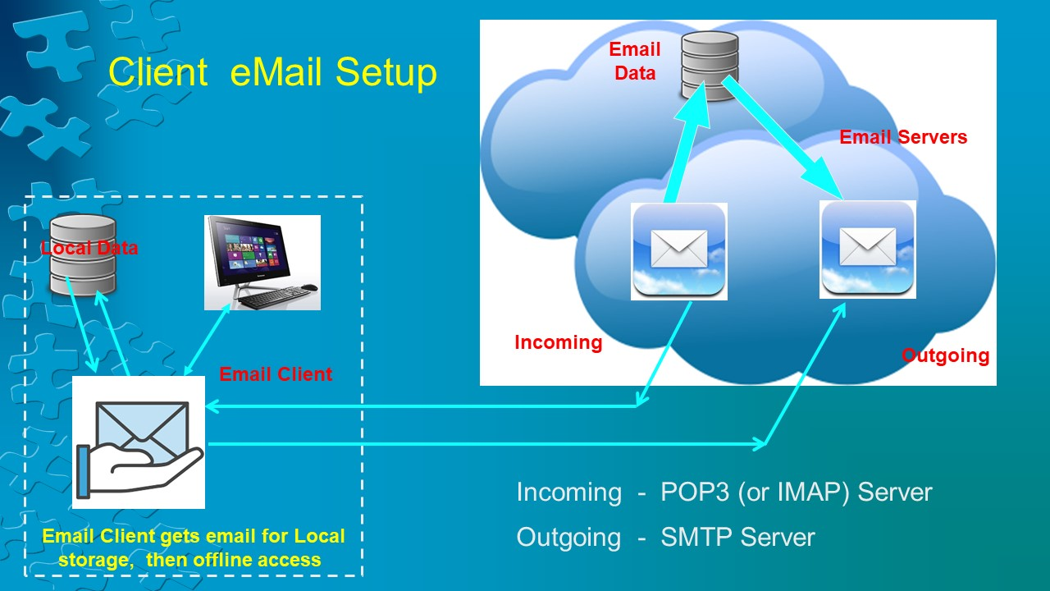

Next Meeting . . . 15-March

Back on our usual room, with topics to include Windows-10 ‘ Tips & Tricks ‘

